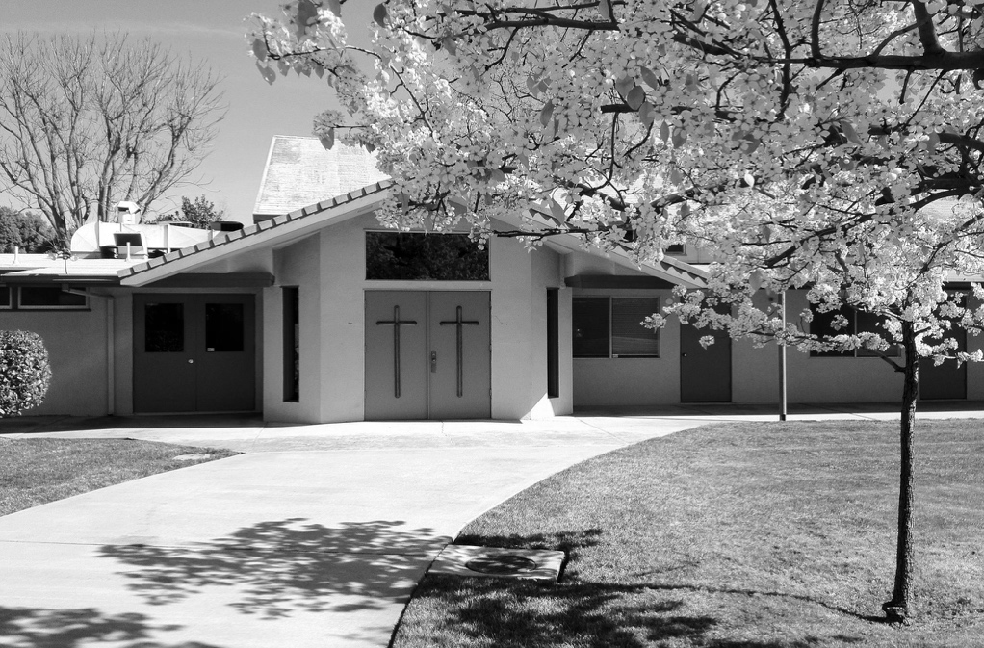
APRIL 2021
VOLUME 4 ISSUE 4

What's INSIDE
2 Board Report
2 Deacon's Corner
3 Update on Giving
3 Special Offerings
4 Pastor’s Letter
5 Calendar
5 Facilities Report
UPCOMING EVENTS
Easter Sunday:
Sunday, April 4 from
11:00am to 12:00pm &
1:00 to 2:00pm

School of Theology:
Monday, April 5 from 7:00 to 9:00pm

Marriage Course
Every Thursday starting April 15 from
7:00 to 9:00pm
Last of all, as though I had been born at the wrong time, I also saw him. For I am the least of all the apostles. In fact, I’m not even worthy to be called an apostle after the way I persecuted God’s church.
I am convinced that it takes more faith to believe that Jesus didn’t rise again, than to trust in his resurrection. And certainly, some have claimed—throughout the years—that Jesus couldn’t have risen again. But imagine for a moment the evidence that must be denied in order to believe this?

(Continued on page 4)
The Sunday After Easter

He is risen … and all of God’s people replied in unison, “He is risen indeed!”
But what if he didn’t rise? What if the tomb stayed sealed, and Jesus stayed dead? What would that mean for the Christian faith, and for you?
The Apostle Paul writes in 1 Corinthians 15: I passed on to you what was most important and what had also been passed on to me. Christ died for our sins, just as the Scriptures said. He was buried, and he was raised from the dead on the third day, just as the Scriptures said. He was seen by Peter and then by the Twelve. After that, he was seen by more than 500 of his followers at one time, most of whom are still alive, though some have died. Then he was seen by James and later by all the apostles.

Publication of Calvary Church, 2343 Country Club Blvd, Stockton, California 95204
THE CALVARY PRESS
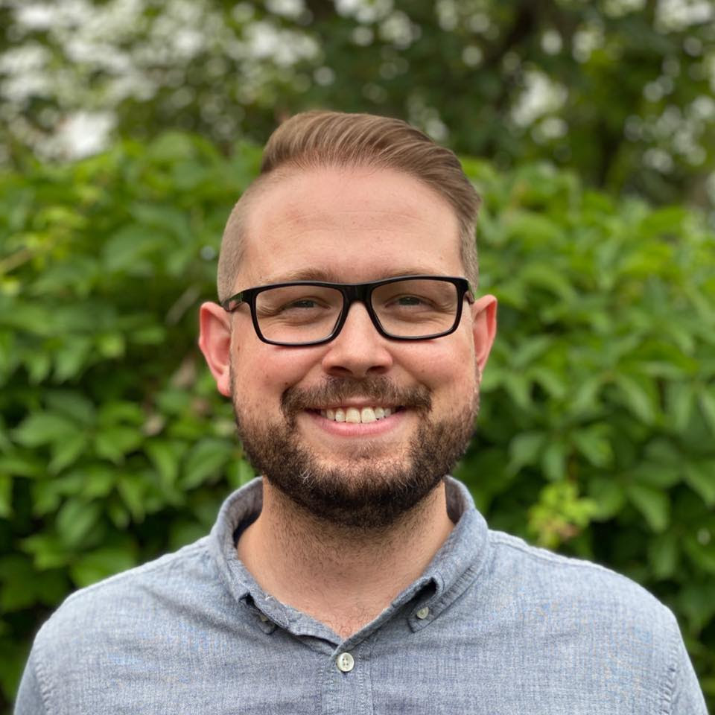

Calvary Press
Page 2
CALVARY BOARD REPORT

February 2021 Financials

Income: $45,957.82

Expenses: $17,804.36

Net: +$28,153.46

During difficult times, such as the COVID pandemic, we may be waiting a lot for things to be back to normal. Have confidence in the Lord. He is doing good work behind the scenes while we wait. Take heart during anxious times. We can wait and look upon the goodness of the Lord.

“Wait for the Lord; be strong and take heart and wait for the Lord.” - Psalm 27:14
We will be having a church clean up day on Friday, April 2 from 4:00pm to 4:30pm. Please email info@calvarystockton.church if you’d like to help out. Thank you!
- Prayer’s for Earl recovering from a double lung transplant.
- Dean’s friend, Rob, battling leukemia.
- For Charise continuing God’s love.
- Linda’s friend’s husband, Al Brown, recovering from a heart attack.
- Prayers for Steve and Barbara’s safe travels to Kansas.
- Continuous prayers for those battling COVID.
- Prayers for those going through personal struggles.
- Prayers for God’s blessings and guidance for Calvary, our pastor and his family and Converge and all Christian churches to be a light in the world.
- Revival of our country to follow Jesus Christ.
PRAYER REQUESTS:
- Blessings for the vaccine and its distribution.
- Blessings for Jeff and Pauline’s wedding.
- Charise thanks God for the simple things in life.
- Kathy’s neighbor, Nita, battling health issues.
- Dave’s friend, Max, recovering from knee surgery.
- Rosie suffering from depression.
- Paul’s decision to enroll in a Christian college.
- Oryan’s job interview with Lawrence Livermore Lab.
- Prayer’s for Norma’s grandson.
- Hisako’s neighbor, Ronnie, recovering from COVID.
- Prayer’s for youngsters dealing with depression.

DEACON’S CORNER

-Brian Kaneko, after prayer and discernment decided to step back as role of Administrative Assistant as of April 19.
-Job for Operations Manager has been posted on Zip Recruiter, Indeed, and Facebook.
Be mindful of the Garbage, Recycle, and Green Waste bins putting correct items only in each bin. Beginning in March, there will be fees for noncompliance.

First Fruit Offering Update:
-Livestream equipment was purchases for approximately $1,900.
-The exterior of the church and the bathrooms are being painted for approximately $5,000.
-$5,000 donation was made to the Converge Church Planting Fund.
-Karen Nakamura was appointed Accounts Payable Manager

Thanks to the generosity of the congregation to our First Fruits Offerings, the Facilities Committee is using their allotment to paint the exterior of the church and painting the restrooms. We are also looking into replacing the flooring in the Social Hall.

BIBLE TRIVIA
- Who baptized Jesus?
_______________________________
- What is the first commandment out of the ten commandments?
_______________________________
- What was Jesus’ crown made of?
_______________________________
- How many Gospels are in the new testament?
_______________________________
Answers from February’s trivia: Bethlehem, 27, 5,000 & Peter.

FACILITIES REPORT

APRIL

SUN | M | T | W | TH | F | SAT
28  Worship  Service:  10:00am | 29  Prayer Night  7:30pm – 8:30pm | 30  Small Group:  7:30pm | 31  Pastor’s Devotion  Small Group:  10:00am  Catalyst Life Group:  7:00pm – 9:00pm | 1  Weekly Email Newsletter | 2  Office closed  Stations of the Cross Service:  1:00pm – 4:00pm | 3
4  Easter Sunday  Worship  Service:  11:00am & 1pm | 5  Prayer Night  7:30pm – 8:30pm  School of Theology:  7:00pm – 9:00pm | 6  Small Group:  7:30pm | 7  Pastor’s Devotion  Small Group:  10:00am  Catalyst Life Group:  7:00pm – 9:00pm | 8  Weekly Email Newsletter | 9  Office closed | 10
11  Communion  Worship  Service:  10:00am | 12  Prayer Night  7:30pm – 8:30pm | 13  Small Group:  7:30pm | 14  Pastor’s Devotion  Small Group:  10:00am  Catalyst Life Group:  7:00pm – 9:00pm | 15  Weekly Email Newsletter  Marriage Course: | 16  Office closed | 17
18  Worship  Service:  10:00am  Membership  Class:  1:00pm – 3:30pm | 19  CP Deadline  Prayer Night  7:30pm – 8:30pm | 20  Small Group:  7:30pm | 21  Pastor’s Devotion  Small Group:  10:00am  Catalyst Life Group:  7:00pm – 9:00pm | 22  Weekly Email Newsletter | 23  Office closed | 24  Men’s Fellowship  Breakfast:  8:00am
25  Worship  Service:  10:00am | 26  Prayer Night  7:30pm – 8:30pm | 27  Small Group:  7:30pm | 28  Pastor’s Devotion  CP Mailing  Small Group:  10:00am  Catalyst Life Group:  7:00pm – 9:00pm | 29  Weekly Email Newsletter | 30  Office closed | 1

Calvary Press
Page 5
Non-Profit Organization
U.S. Postage Paid
Stockton, California
Permit No. 161

Calvary Church
2342 Country Club Blvd
Stockton, California 95204

We are a welcoming, casual and diverse church in the heart of Stockton’s beautiful Country Club neighborhood. We are a community where you are welcomed whether you are new to faith or a lifelong follower of Jesus.

For more information call: 209-466-0221 or email: info@calvarystockton.church
Visit our website: www.calvarystockton.church or Facebook: www.facebook.com/calvarystockton

Office Hours: Monday through Thursday from 8:30am to 5:30pm

Wednesday Prayer Walk
Every Wednesday
2pm to 3pm

Small Groups
Tuesday Night: 7:30pm
Wednesday morning: 10am
Wednesday night: 7pm
Get involved in weekly ministries:
Worship service
Every Sunday
10am to 11am

Prayer Night
Every Monday
7:30pm to 8:30pm

Calvary Church “Centering People in Christ”

RETURN SERVICE REQUESTED

Glory in His holy name; let the hearts of those who seek the LORD rejoice!

Address label

Page 3
Calvary Press

NEW ONLINE AND RECURRING GIVING OPTION

GO TO: www.calvarystockton.church/give to set up giving online
You can now make your regular tithes and offerings through
credit/debit card, either online through our website or by
filling out an offering envelope! To get started with card
giving today, simply fill out an offering envelope with your
card details and return it to the church office, or go to
www.calvarystockton.church/give to set up your gift straight
away. We encourage you to give online so you can
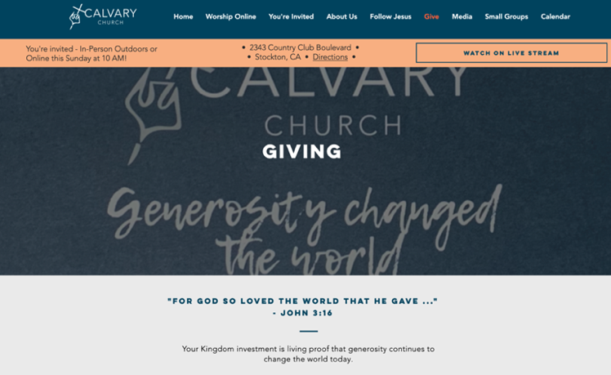
automate your tithe or offering by having it automatically be taken from your card. You can select weekly, bi-weekly or monthly giving in any amount and on any day of the month. It’s a safe, convenient and secure way to make sure you stay up to date on your giving and honor God with your finances. Plus, through setting up a giving account online, you get immediate access to your giving history and tax-deductible receipts.
FAQ
Is there a processing fee for my gift? - Yes.
We partnered with an industry-leading card
processing company that offers the lowest
processing rate in the industry for churches.
However, to ensure your full amount goes to the
church you can offset the card processing charge.
For online giving, just click the box labelled
“Increase my donation to $_______ to cover the
transaction fee.” If you’re giving by card through envelope, simply increase your gift by 3%
Is it safe? - Yes. The company that processes the cards is used by churches across the world, as well as by large Fortune 500 companies including Amazon and Google.
Do you store my card information? - No. For online giving we never even see your card details. All information is stored directly by the card processor using industry-leading encryption. For card information on offering envelopes, we immediately shred the envelop after processing your gift. Card details on envelopes are only seen by the Calvary treasurer(s).
Marissa
(Example - $100, increase gift to $103; $50, increase gift to $51.50).

In Memory of Tadashi Agari
Robert Tanaka
In Memory of Ben Hamamoto  Gary Hamamoto  Birthday Fund  Willie & Anna Low (Willie & Stephanie’s birthdays)  Jim & Sally Tsunekawa (Rin’s 2nd birthday)  Deacon’s Fund  Aiko Aoyama  Roy & Emily Takeuchi (In memory of Tadashi Agari)  Sumi Yonemoto  Ruth Yoneshige | In Memory of Brandon Wehrli
Jim & Sally Tsunekawa (Erin’s 2nd birthday) | Willie & Anna Low  Jerry & Karen Nakamura  Joyce Nakashima  Duane & Jeannie Sakoda  In Memory of George & Amy Matsumoto  Janie Low  In Memory of Katie Komure  L H Nagata

Easter
Aiko Aoyama
Susie Hamamoto
Lilly Hatanaka
Irene Ishida
Tadashi & Carolyn Ishihara
Marissa Ishihara
Janice Ishimaru
Mary Lam
Charisa Masada
Sam & Sumiko Motoike
Jerry & Karen Nakamura
Gary & Sandy Nakashima

Easter
Ren & Julianne Nakashima
Dorothy Nishioka
Tak & Linda Saito
Carolyn Sakai
Duane & Jeannie Sakoda
Kate Salamon
Hisaye Takahashi
Sam & Kinuyo Tanaka
Jim & Sally Tsunekawa
Ray & Judy Yamagishi
Sumi Yonemoto
Ruth Yoneshige

SPECIAL OFFERINGS

Page 4

For more encouraging devotionals
Go to our website www.calvarystockton.church/blog for a new devotionals every Wednesday.
It’s a great way to get uplifted and to be filled with the Holy Spirit during the week!

The empty tomb – if Jesus stayed dead – would not have stayed empty. Yet the stone was rolled away and the tomb was vacant. No one has ever produced the body of the most famous figure in all of recorded human history.
The Apostle Paul writes that over 500 people personally witnessed the resurrection of Jesus. Many of them would later be killed and persecuted for their faith. If they were deceiving people, they could easily have told people the truth. Yet they couldn’t deny, and were willing to die for, the truth that they had seen and experienced the risen Christ!
I imagine what it must have been like for the disciples to walk alongside Jesus the Sunday after Easter, after witnessing the miracle of his resurrection. They strolled with him on the beach, touched the holes in his hands where he had been nailed to the cross, and saw first-hand the power of his resurrection miracle.
Yet as much as I dream of seeing him the week after Easter, I also believe that you and I don’t have to be transported back 2000 years to witness the resurrected Jesus. Because you already see him at work in your life, in the way he is transforming and resurrecting you each and every day.

Calvary Press
Page 4
And that’s the most confident evidence of Jesus’ resurrection that I can point to. It’s that, billions of Christians around the world today still experience the risen Christ. And you too are one who, as a follower of Jesus, experience the risen Christ in your life.
Paul writes: since we preach that Christ rose from the dead, why are some of you saying there will be no resurrection of the dead? For if there is no resurrection of the dead, then Christ has not been raised either. And if Christ has not been raised, then all our preaching is useless, and your faith is useless
If Jesus has not been raised. If the tomb is full. If the disciples, and the witnesses and the billions of people around the globe who have experienced him are all lying. Then your faith is dead, and my preaching is useless.

Thank God he has resurrected you. Thank God he is risen. Thank God he is risen indeed.

Yours in Christ,
Pastor Andrew

(continued from page 1)

